**Machine Learning Applications Project**

**Image Class Prediction & Viewer (Flet + TensorFlow)**

**Project Descriptions:**

This is a desktop/web application built with Flet, TensorFlow, and MobileNetV2 that allows you to:

* Upload an image
* Predict its class using a pre-trained classifier
* Display similar images from a local or database-backed dataset
* Retrain the model directly from the interface

**Features**

* Upload and view images instantly
* Predict class using a Keras model
* Feature extraction using **MobileNetV2**
* Show related images based on prediction
* Retrain model on-the-fly with a button click
* SQLite or PostgreSQL-compatible backend (via db_utils_CNN.py)

**UI Overview**

* **Image Preview**: Displays the uploaded image.
* **Prediction Text**: Shows predicted class and confidence.
* **Slider**: Select how many related images to show.
* **Related Images Grid**: Shows thumbnails from dataset.
* **Retrain Button**: Trigger training script (retrain.py) from UI.

**Requirements**

* Python 3.8+
* flet
* tensorflow
* pillow
* numpy
* psycopg2-binary (if using PostgreSQL)
* Pre-trained classifier saved (e.g., model.pkl via joblib)
* Optional: PostgreSQL with a photo_dataset table (see db_utils_CNN.py)

**Project Code Files :**

1. **app_CNN.py**
2. **db_utils_CNN.py**
3. **model_utils.py**
4. **retrain.py**

**Project Working in Detail and the Codes:**

1. db_utils_CNN.py

This python code is used to load the data from the database using CNN to extract features .

***Code***:

import sqlite3

import random

import numpy as np

from PIL import Image

from io import BytesIO

from tensorflow.keras.applications import MobileNetV2

from tensorflow.keras.applications.mobilenet_v2 import preprocess_input

DB_PATH = "photo_database.sqlite"

cnn_model = MobileNetV2(include_top=False, weights='imagenet', pooling='avg', input_shape=(128, 128, 3))

def load_dataset_from_db():

    X, y = [], []

    conn = sqlite3.connect(DB_PATH)

    cur = conn.cursor()

    cur.execute("SELECT image_label, image_data FROM photo_dataset")

    for image_label, image_data in cur.fetchall():

        try:

            img = Image.open(BytesIO(image_data)).convert('RGB').resize((128, 128))

            img_array = np.array(img).astype("float32")

            img_array = preprocess_input(img_array)

            features = cnn_model.predict(np.expand_dims(img_array, axis=0), verbose=0)[0]

            X.append(features)

            y.append(image_label)

        except Exception as e:

            print(f"Error processing image from DB: {e}")

    conn.close()

    return np.array(X), np.array(y)

def get_random_images_by_label(image_label, count=5):

    conn = sqlite3.connect(DB_PATH)

    cur = conn.cursor()

    cur.execute("SELECT image_data FROM photo_dataset WHERE image_label = ?", (image_label,))

    rows = cur.fetchall()

    conn.close()

    selected = random.sample(rows, min(count, len(rows)))

    return [row[0] for row in selected]

1. model_utils.py

This python code is used to train a randomforest model and store it into a file named “model.pkl”

***Code:***

import pickle

from sklearn.ensemble import RandomForestClassifier

from sklearn.model_selection import train_test_split

from sklearn.metrics import accuracy_score

import numpy as np

MIN_ACCURACY = 0.35

MODEL_PATH = "model.pkl"

def train_model(X, y):

    model = RandomForestClassifier(n_estimators=100, random_state=42)

    X_train, X_test, y_train, y_test = train_test_split(X, y, test_size=0.2, stratify=y)

    model.fit(X_train, y_train)

    acc = accuracy_score(y_test, model.predict(X_test))

    print(f"Training Accuracy: {acc:.2%}")

    if acc >= MIN_ACCURACY:

        with open(MODEL_PATH, "wb") as f:

            pickle.dump(model, f)

        return model, True

    return None, False

def load_model():

    with open(MODEL_PATH, "rb") as f:

        return pickle.load(f)

1. app_CNN.py

This Python code is the main interface for an image classification app using Flet. It allows users to upload an image, predicts its class using a pre-trained model, and displays similar images from a database. It also includes a slider to control image count and a button to retrain the model via a subprocess call to update predictions.

***Code:***

import flet as ft

import numpy as np

from PIL import Image

import base64

import subprocess

from io import BytesIO

from model_utils import load_model

from db_utils_CNN import get_random_images_by_label

from tensorflow.keras.applications import MobileNetV2

from tensorflow.keras.applications.mobilenet_v2 import preprocess_input

import tensorflow as tf

clf = load_model()

class_labels = clf.classes_

cnn_model = MobileNetV2(include_top=False, weights='imagenet', pooling='avg', input_shape=(128, 128, 3))

def preprocess_image(path):

    img = Image.open(path).convert('RGB').resize((128, 128))

    img_array = np.array(img).astype("float32")

    img_array = preprocess_input(img_array)

    features = cnn_model.predict(np.expand_dims(img_array, axis=0), verbose=0)

    return features

def main(page: ft.Page):

    page.title = "Image Class Prediction & Viewer"

    page.scroll = ft.ScrollMode.AUTO

    uploaded_img = ft.Image(width=300, height=300, fit=ft.ImageFit.CONTAIN)

    status_text = ft.Text()

    num_slider = ft.Slider(min=1, max=10, divisions=9, label="{value}", value=5)

    image_grid = ft.Column(scroll=ft.ScrollMode.AUTO, auto_scroll=False)

    def display_images_in_rows(images):

        image_grid.controls.clear()

        row = ft.Row(wrap=True, spacing=10, run_spacing=10)

        for i, img_data in enumerate(images):

            encoded = base64.b64encode(img_data).decode("utf-8")

            img_widget = ft.Image(

                src_base64=encoded,

                width=200,

                height=200,

                fit=ft.ImageFit.CONTAIN

            )

            row.controls.append(img_widget)

            if (i + 1) % 3 == 0:

                image_grid.controls.append(row)

                row = ft.Row(wrap=True, spacing=10, run_spacing=10)

        if row.controls:

            image_grid.controls.append(row)

        page.update()

    def on_upload(e: ft.FilePickerResultEvent):

        if e.files:

            path = e.files[0].path

            uploaded_img.src = path

            uploaded_img.update()

            image_grid.controls.clear()

            status_text.value = "Predicting..."

            page.update()

            input_array = preprocess_image(path)

            probs = clf.predict_proba(input_array)[0]

            best_idx = np.argmax(probs)

            confidence = probs[best_idx]

            predicted_label = class_labels[best_idx]

            if confidence < 0.30:

                status_text.value = f"Prediction confidence too low ({confidence:.2%}). No image shown."

                page.update()

                return

            status_text.value = f"Predicted Label: {predicted_label} (Confidence: {confidence:.2%})"

            images = get_random_images_by_label(predicted_label, count=int(num_slider.value))

            display_images_in_rows(images)

            page.update()

    def retrain_model(e):

        status_text.value = "Retraining model..."

        page.update()

        result = subprocess.run(["python", "Image_recognition\\retrain.py"], capture_output=True, text=True)

        if result.returncode == 0:

            status_text.value = "Model retrained successfully. Reloading..."

            global clf

            clf = load_model()

            status_text.value = "Model reloaded and ready to use."

        else:

            status_text.value = f"Retraining failed:\n{result.stderr}"

        page.update()

    file_picker = ft.FilePicker(on_result=on_upload)

    page.overlay.append(file_picker)

    page.add(

        ft.Text("Upload an image:"),

        ft.ElevatedButton("Select Image", on_click=lambda _: file_picker.pick_files(allow_multiple=False)),

        uploaded_img,

        status_text,

        ft.Text("Number of images to display:"),

        num_slider,

        ft.Text("Images from predicted label:"),

        image_grid,

        ft.ElevatedButton("Retrain Model", on_click=retrain_model, bgcolor=ft.colors.BLUE, color=ft.colors.WHITE),

    )

ft.app(target=main)

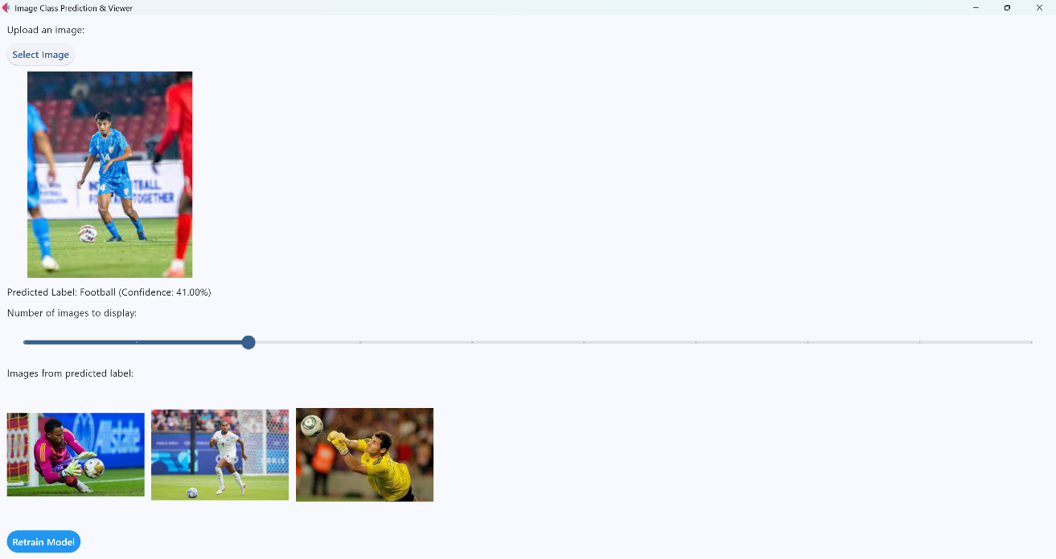**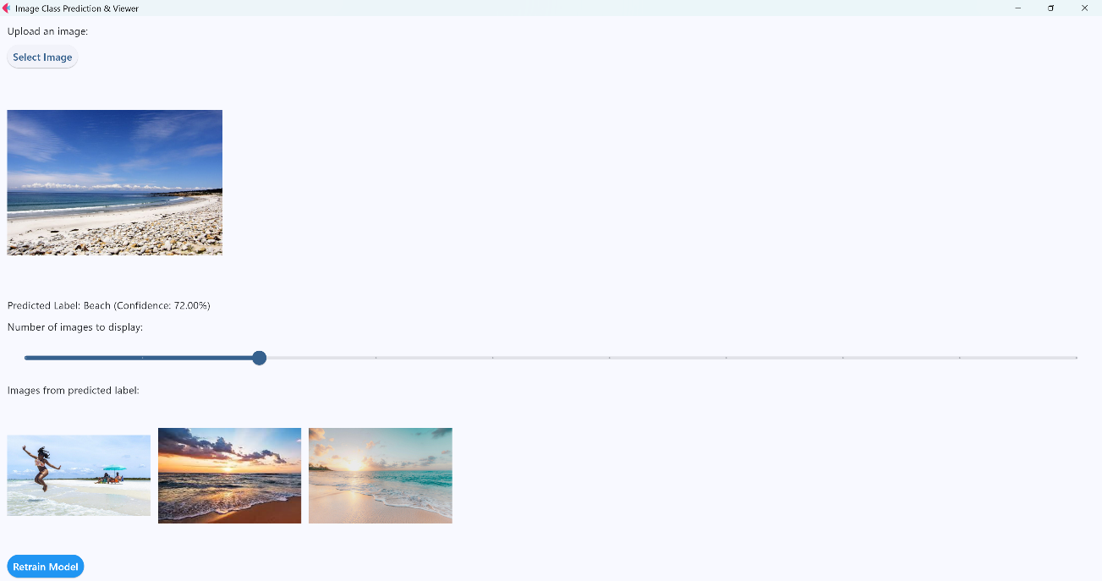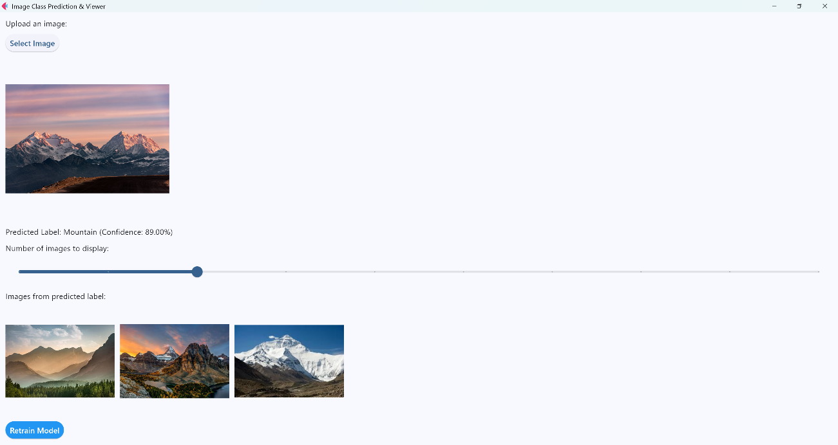Sample Run of the Project :**